Conductive Rubber Circuit and Simulation

R_Band = Conductive Rubber

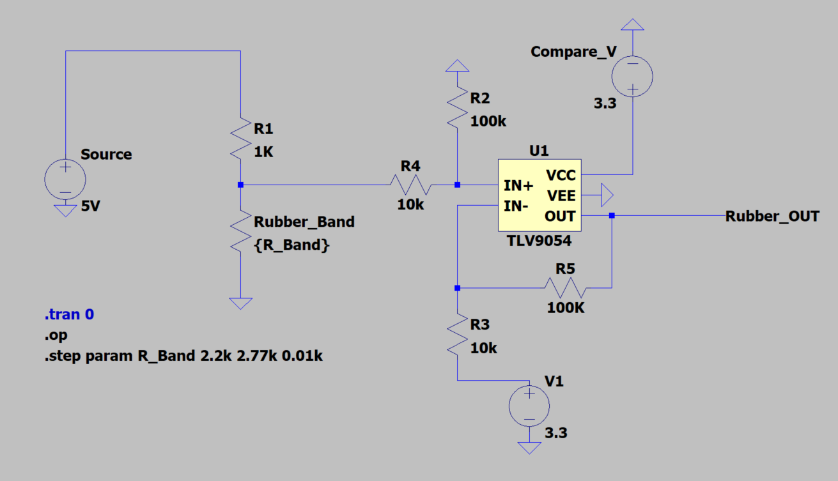

Changed R5 to 32kohm

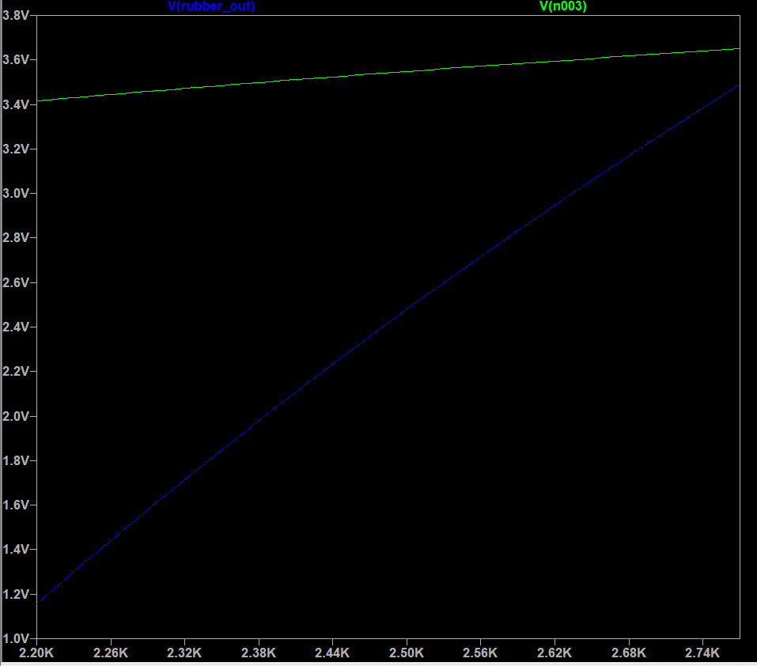

Green: original Output

Blue: amplified Output

Thermistor Circuit and Simulation (might be overdesigned but im too lazy to figure out the easy way… )

R_Temp = Thermistor

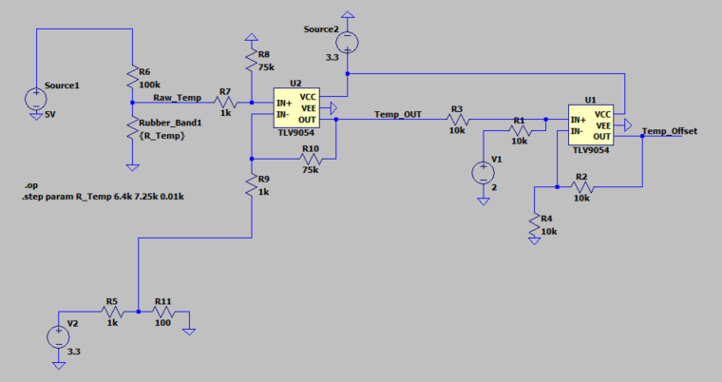

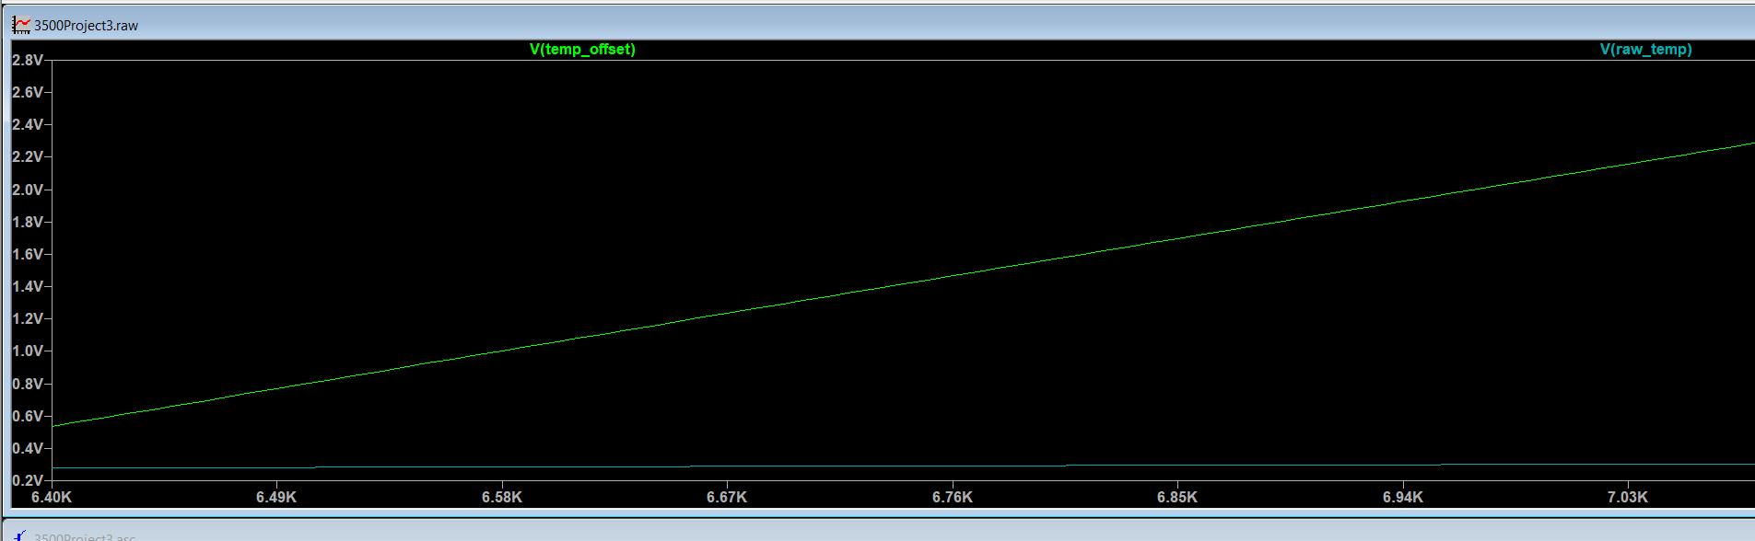

Green: Value after Offset  
Blue: Original Value

Resistance value between 9.3k to 10.3k